**GIT**

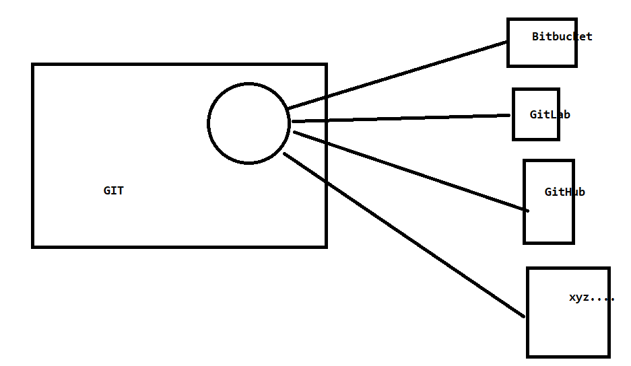

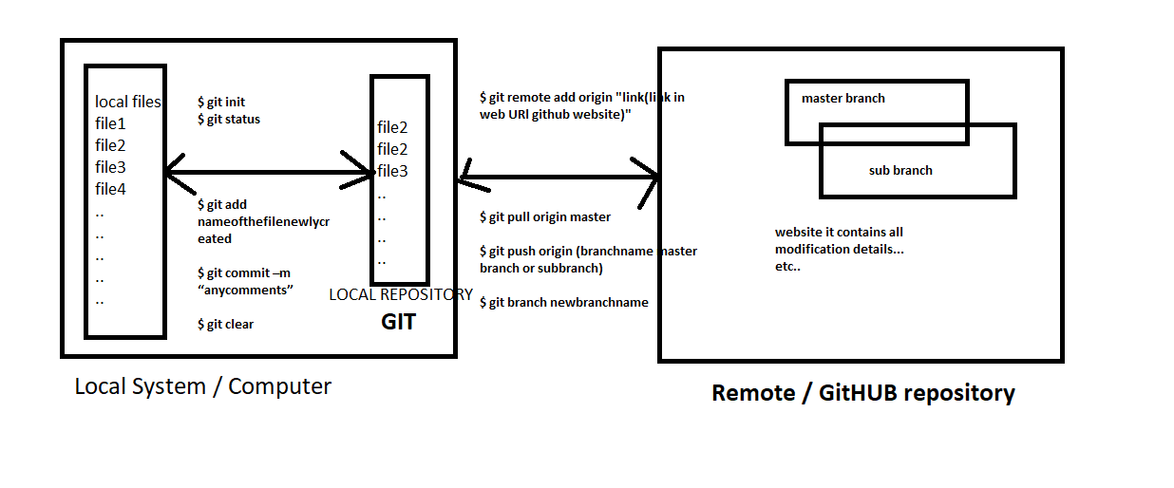

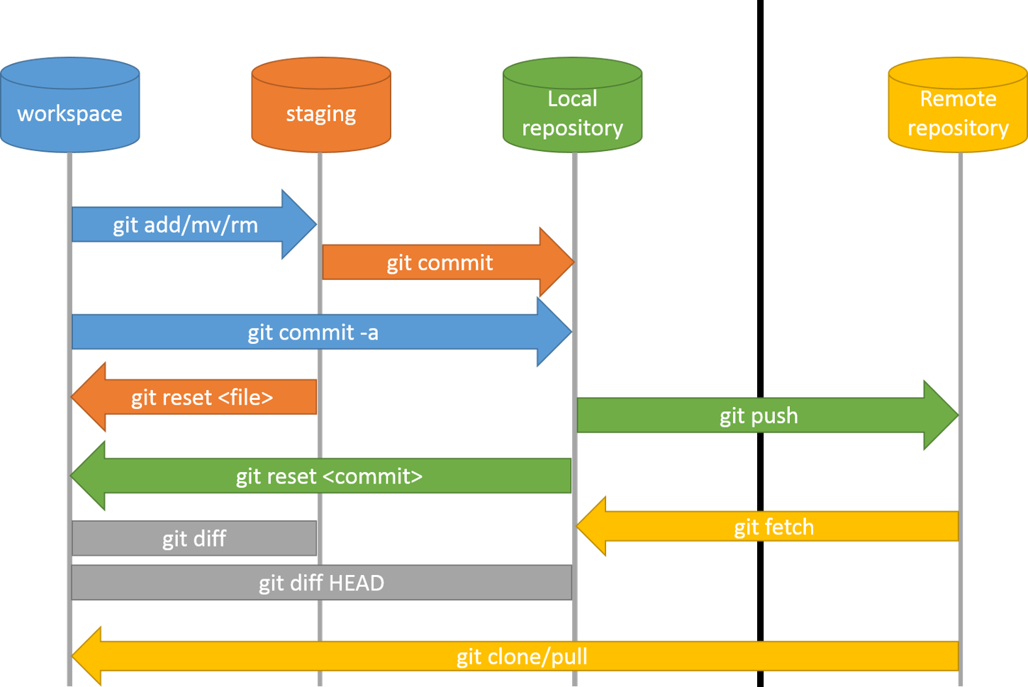

**“HEAD” means?**

Latest commit.

The HEAD **points out the last commit in the current checkout branch.**

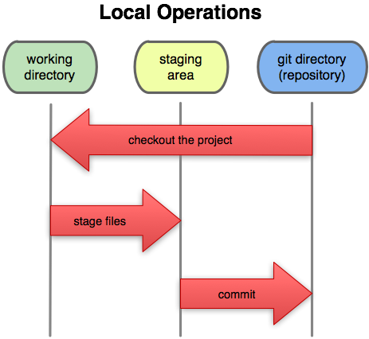

Github alternative.--> Search in google you will get lots of results.

Eg :<https://www.tecmint.com/github-alternatives-to-host-open-source-projects/>

First Install GIT software in your local system.

[**https://git-scm.com/**](https://git-scm.com/)

Install TortoiseGit:

<https://tortoisegit.org/download/>

**BitBucket Latest POC:**

**Creating new repository and pushing local project to remote repository.**

**1.**First create bitbucket account and create one repository there.

Now go to your system and create any folder and do the below steps.

1. -/>**git init** --> initializing local repository in any folder in your system.

2. -/>**git remote add origin**[**https://kamalshaik@bitbucket.org/kamalshaik/<namevariesdependsonrepo>.git**](https://kamalshaik@bitbucket.org/kamalshaik/%3cnamevariesdependsonrepo%3e.git)

For linking the local repository and remote repository.

Here repository name that you have created earlier.

To put our project from our local machine to git remote repository.(first time while putting our local project to remote repository)

3.-/>**git add -A** or**-/>git add .** --> staging or adding files to index. What is meant by staging???

4. -/>**git commit -m "comments"** --> committing files to local repository.

5. -/>**git push -u origin master**

After the above 4 points, this command is to push our code to remote repository we need to use this command.

6. If you want to switch between branches by git commands use below command:

**-/>git checkout branchName/child or master name**.

This command should be used after **git fetch / git pull**request only, because newly created branch will not be updated in you system until you execute fetch / PULL command from your local system/ repo.

-/>**git log** : to see commited files and their hash codes / Version id / Commit id.

**-/>git log –oneline :**to see commited files and their hash codes in single line on console.(2 hypen’s)

->How to see all remote and local branched in GIT repository?

**-/>git branch** (Tells current working branch.)

**-/>git branch –r** (show only remote branches)

**-/>git branch –a(show all local and remote branches)**

🡪How to revert the local changes with remote repository files.(untracked files🡪not staged or not committed).

**-/>git checkout . (dot) :**  all local changes will be removed and your work space will be clean.

If you delete any files, those files also will be added from remote repository.

If you want to revert the local changes of one specific file then use below command.

**-/>git checkoutfilePath**

Eg :**-/>git checkout src/main/java/org/EmplyeeService/App.java**

Note: But to get the file specific path use **-/> git status** command and copy that path and use in above

command.

Note: If you are in some specific inner folder path and if you execute **-/>get checkout .**, then only inner folders files will over ridden by remote files.

🡪How to revert the committed file changes

|  |
| --- |
| IF you have NOT pushed your changes to remote repo (to make tracked files as untracked files)  **-/>git reset HEAD~1**  Check if the working copy is clean by git status.  ELSE you have pushed your changes to remote then use below command  **-/>git revert HEAD**  This command will revert/remove the last one commit/change and then you can push.  If you do GIT PUSH then only changes will be back in server repository.  It will open UNIX terminal add comments and use **:wq** to go back to normal state in terminal. |

**Head** means last commit representation.

How to create new branch from existing branch through command prompt:

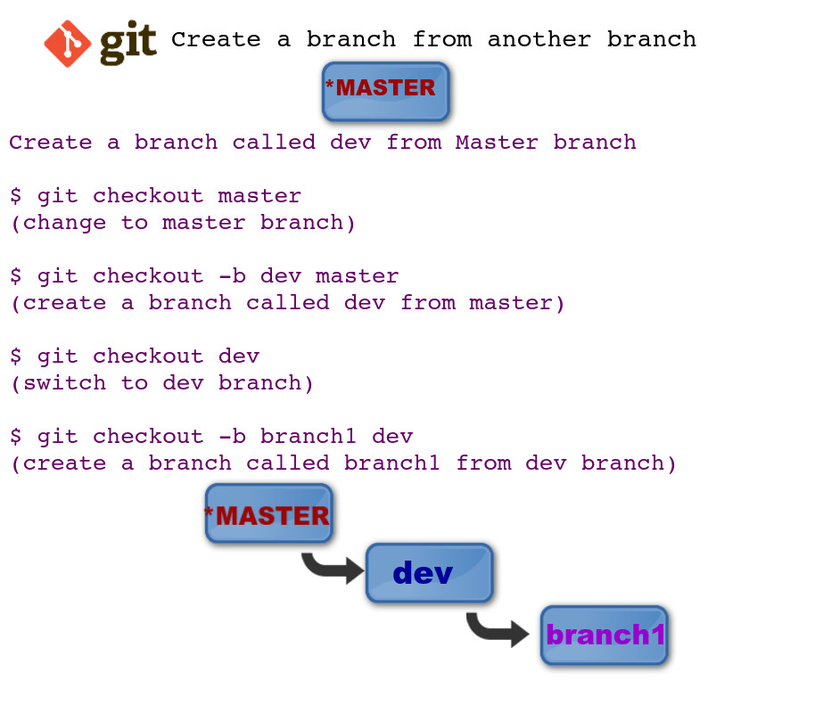

🡪How to check committed files differences for a particular commits?

For this we need to take help of TortoiseGit.

Go to your project folder and right click you will get below options.

(For this first tortoise Git should be installed in your system.)

TortoiseGit->Diff With Previous Version🡪Open Git window like below.

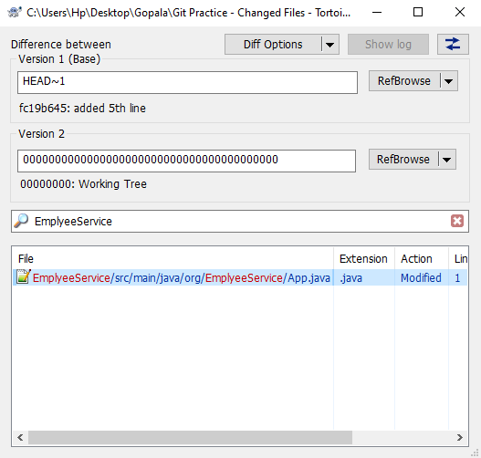

Here version 2 means current working remote repository code(Fresh Code).

Here Version 1 (Base) means previous code to version 2.

If you want to check/compare with history code commits. Then bring the history commit id / commit hash code and compare.

To get previous commit hash code use **-/>git log(OR)-/> git log --oneline** command.

Copy required history commit hash code and add in version 1 input box then automatically list of files will be shown below. Check files by double click and do required changes.

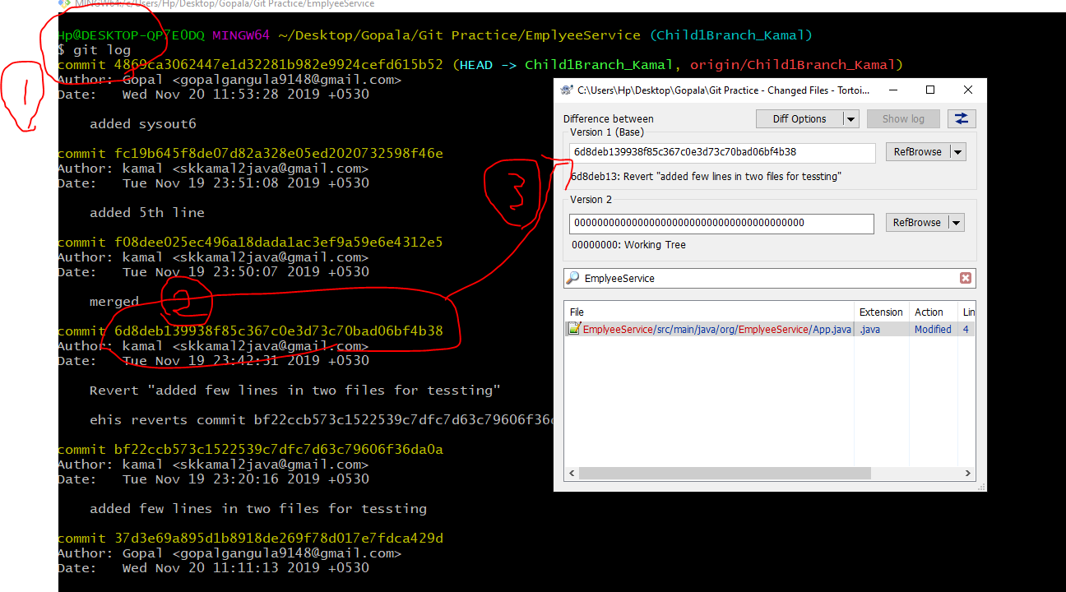

-->How to see committed files before push them to remote repository?

**-/> git log**

-------------------------------------------------------------------------------------------------------------------------🡪

🡪 How to revert back recent remote repository changes completely?

**-/>git reset --hard gitversion**

For example, let’s assume we are having 10 commits to remote repository.

1…to 10 with different commit id’s. Assume Here 10th commit is latest.

Now let’s take 5th commit id for resetting / for testing. Use **git log**command for getting commit id’s of all previous commits.

**-/>git reset --hard 37d3e69a895d1b8918de269f78d017e7fdca429d**

If you run above command then 6 to 10th commits data will be lost and 5th commit will be our latest code.

Means above given commit id code will be our latest code in repository.

But running above command is not sufficient, after the above command we need to run one more command given below.

**-/>git push -f origin brnachname**

**Eg :git push -f origin Child1Branch_Kamal**

After this command all latest to given commit id data will be lost. You can check with git log command.

|  |
| --- |
| git reset --hard 37d3e69a895d1b8918de269f78d017e7fdca429d  git push -f origin Child1Branch_Kamal |

**\*\*\*\*\*\*Warning : Think before using this command , it may delete others commits also.**

<---------------------------------------------------------------------------------------------------------------------------

**Git Stash:**

**-/>git stash** or -/>**git stash save “description comments about your task.” (OR) -/> git stash push –m “Comments”**

-/>**git stash list** -> to see all your stashed ids.

-/>**git stash applycompletestashID / IndexNumberofStashID**-> to apply old stash to our code / taking back old code

from stash cache. Get the stash id from git stash list.

If you do like this stash data will applied and old stash id still will be there in cache, you can see this one by git stash list.

eg: -/>git stash apply stash@{1} / -/> git stash apply 1

**-/>git stash popStashIndexNumber**this is also applying stash but in this case stash id will removed from stash cache memory.

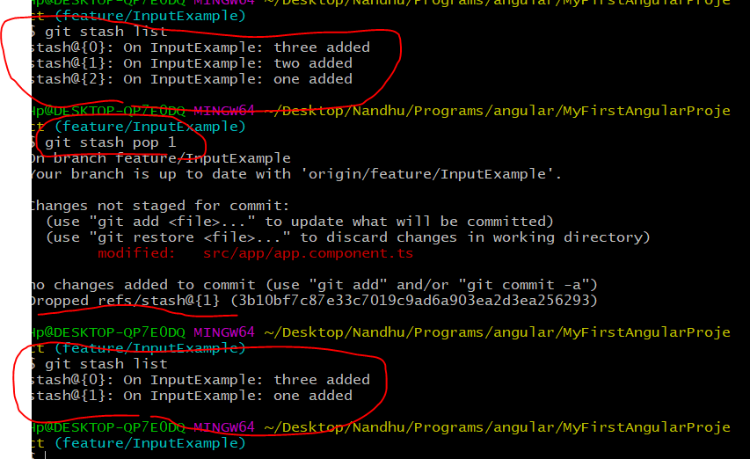

-/>**git stash clear** -> Complete git stash memory will be erased for cache.

-/>**git stash drop stash@{1}** -> if you want to drop/clear one individual stashId from cache.

Check :

<https://www.gitkraken.com/download/windows64>

Example :

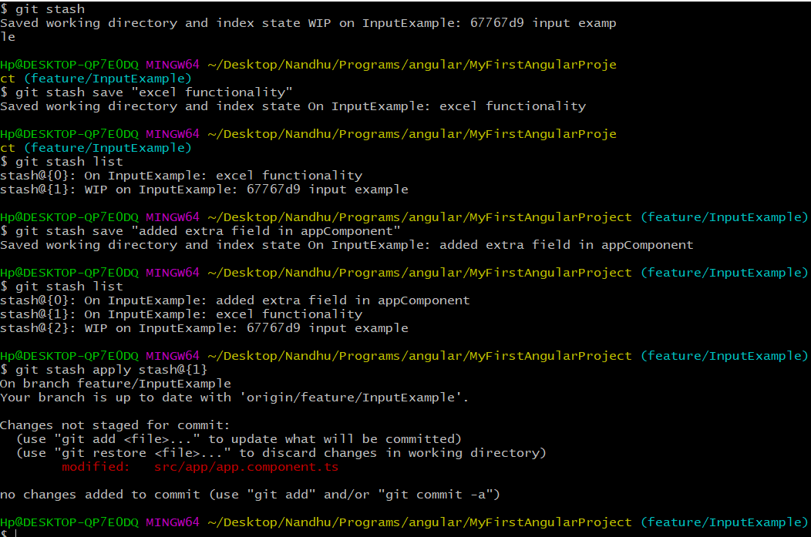

**We can apply only one stash at a time. If you want to apply another stash to already stash applied code, either you commit that code or take latest code by using (git checkout .) command.

**\*\*\* Only local changes and staging changes we can stash but not committed changes.**

<https://www.youtube.com/watch?v=KLEDKgMmbBI&t=417s>

<https://www.youtube.com/watch?v=KLEDKgMmbBI>

<https://www.youtube.com/watch?v=jJFd__VX-GU>

<https://www.youtube.com/watch?v=DeU6opFU_zw>

**Fork?**

**Merge?**

**Rebase ?**

**Create Patch?**

**squash?**

**.gitignore🡪**<https://www.atlassian.com/git/tutorials/saving-changes/gitignore>

**-/>git fetch ?**

**C:\Users\Hp\Desktop\. git\config**

We can do git checkout and git fetch at a time like below.

-/>**git fetch && git checkout feature/branch1**

->Can we add multiple projects in single repository???? Yes we can add happily. But nor recommended.

->While committing the angular project how to avoid committing node_modulesfolder.?

<https://git-scm.com/docs/gittutorial>

<https://www.edureka.co/blog/git-tutorial/>

<https://support.beanstalkapp.com/article/1004-how-do-i-undo-things-in-git>

<https://gist.github.com/delwar2016/c0be7b1ed305525f43fe87fa54ab9c53>

|  |
| --- |
| 1. create PR from master to kamal/your branch in bitbucket.  (Assume no conflicts while raising PR-Pull Request)  (Master--> Kamal-angular-practice-code)  2. go to local there take pull request, all github(Kamal/Your branch )  changes will come to local machine(If no conflicts between local data  and Kamal/PersonalBranch).  Kamal-angular-practice-code--> Local machine  3. Now do modifications commit,push, raise PR to master.  ---------------  1. create PR from master to kamal/your branch in bitbucket.  (Assume no conflicts while raising PR-Pull Request)  Master--> Kamal-angular-practice-code  2. go to local there take pull request,  If ther are conflicts between local data and Kamal/PersonalBranch).  Kamal-angular-practice-code--> Local machine  3. go to your local code.  git commit (existing changes anything are there)  git push (it will fail dont worry.)  git pull (Now both changes appear in local machine)  Now do the modifications accordingly/ remove conflicts manually.  git commit  git push  raise PR to master.  ---------------  3rd Scenario:  While raising PR from master to kamal_Branch(feature Branch)  assume if we got conflicts.  If you try to approve and merge, merge will fail.  (Master--> Kamal-angular-practice-code)  Then,Gotocmd line/git bash.  git checkout master(from branch)  git pull  git checkout ourBranch/Kamal_Branch(to branch)  git merge master (means merge from master to ourBranch)  Now both changes will be there in Local,remove conflicts manaullay,  change code accordingly.  Git commit  git push  if you go and check bitbucket PR will be merged/ if not merge again.  -------------------  your changes you staged,committed and when trying to push it is telling  conflits,  How to resolve this ??  -------------------  changes added to index(staging), but i want revert the staged changes.  ------------  changes committed to local Repo, but i want revert the committed changes.  ------------  changes pushed to server Repo, but i want revert the pushed changes.  ------------  how to see the diffrence between files from local repo to remote repo.  ------------  how to repalce local repo code with previos commit version code.  ------------  Code comparision between previous commits.  -----------  how to check commit history.  ------------ |

Please remember local system means our local system / computer, local repository means repository which available in our local system it is also called GIT, remote repository means repository available at serverit is also called as GITHUB.

->First files will be committed from local system to local repository(GIT) and then only **pushed**from local repository to remote repository(GITHUB).

**Local System🡨-🡪add/commit/---🡪local Repository(GIT)<---push/pull----🡪Remote repository(GITHUB)**

**GIT Command Prompt:**

1.GIT BASH Emulator.(linuxdevelpers)

2.GIT CMD(Windows).

3.GIT GUI(Graphical User Interface)...

Commands used in GIT BASH command promptorGIT BASH Emulator:

|  |
| --- |
| -->**$ git init** -- To create local repository in your system(it will create hidden folder with name **.git**).  --> **$ git config user.name "yourName"** - register for committing and pushing files.(Appear while adding files to local  repo)  -->**$ git configuser.email "yourMailId"** - register for committing and pushing files.  or  -->**$ git config --global user.email "you@example.com"**  **🡪$ git config --global user.name "Your Name"**  **🡪$ gitconfig –list –** To see all configured details in you git.  **🡪$ touch filename.txt –** To create new file in folder by commands.  -->**$ git status** - To check files status that you modified/newly added..etc.  -->**$ git add nameofthefilenewlycreated** - To add newly added files to index / Staging after this only commit can be done.  $ git add webservice.txt or **git add –A** (for multiple files).  **$ git add –A**To add multiple files to index / staging at a time.  -->**git reset HEAD filename1 fileName2..** – If you want to remove file from indexing /staging area use this command.  --> **$ git commit –m “anycomments”** - To move local system file to Local Repository.  **$ git commit –a –m “anycomments”** To move multiple local system file to Local Repository.  -->**git clone gitwebpath** to get github project to local folder(remote repository to local repository.)  Eg : git clone https://github.com/xyz/SBinetSolve.git  -->**$ git remote add origin "link(link in web URlgithub website)"** - map local repo to remote repo.  eg: $ git remote add origin [https://github.com/fullName/MyFilesAndProject.git(we will get from website)](https://github.com/fullName/MyFilesAndProject.git(we%20will%20get%20from%20website))  🡪**$git remote –v** – to see git remote location/ git origin link.  -->**$ git pull origin (branchname master branch or subbranch)**- pull files from remote repository to local  repository.  --> **$ git push origin (branchname master branch or subbranch)** - To push files to local repository to Remote  repository.  Eg: $ git push origin master **or**sub1. Here sub1 is programmer created branch name.  -->**$ git clear** - to clear the GIT Bash simulaotor / GIT command prompt.  -->**$ git branch newbranchname** - to create new branch under master branch.  -->**$ git checkout newbranchname** - To move one branch to another branch in GIT BASHit is similar to cd command  in command prompt..  -->**$ git help commandName** – To know complete command details.  Or  🡪**$git CommandName -- help** |
|  |
|  |

4



Download and install git software from below website:

<https://git-scm.com/downloads>

<https://www.youtube.com/watch?v=xuB1Id2Wxak&t=2s>

staging????

🡪git clone to the central repository with local repository

🡪

->To work with GIT you need an account in github website. For creating github account goto URL..

<https://github.com/> there it is creatre account by providing minimal information.

1. 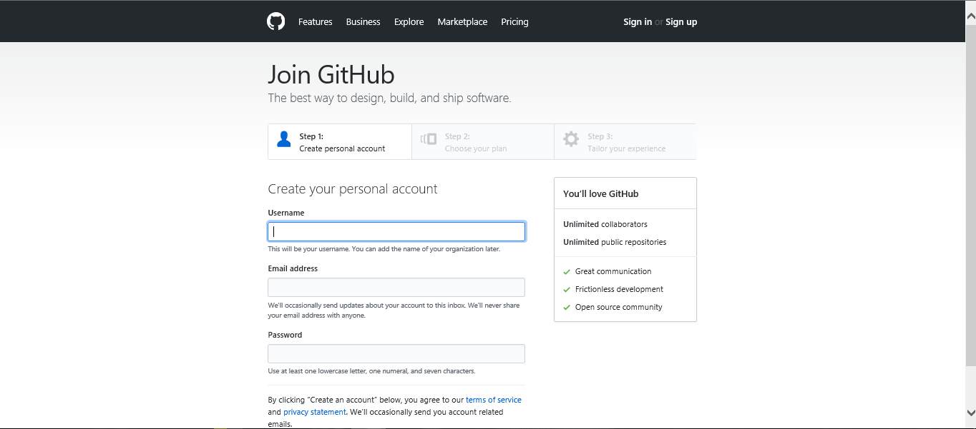
2. 

After creating it looks like below..

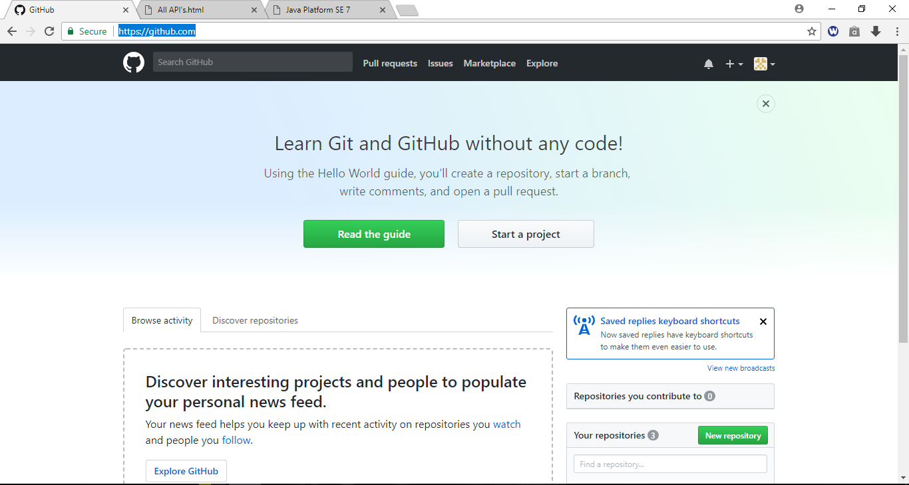

->Next click on Start a Project

->Next by giving unique repository create repository.

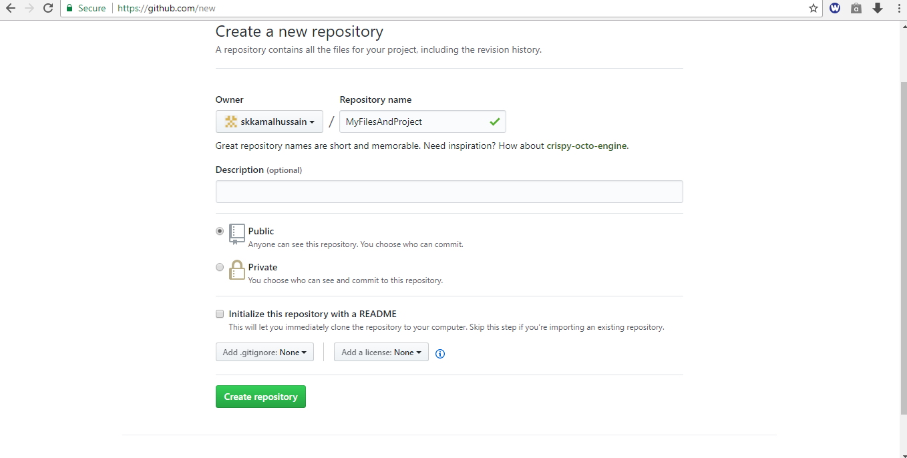

->Nowgoto system folder and create local repository(Just create one folder in any drive),

For creating this first you need to install GIT in your local machine.

->Create folder anywhere in the system..open that folder and right click then you will get GIT BASH HERE option

Then you will get GIT BASH command prompt it is called as GIT BASH EMULATOR.

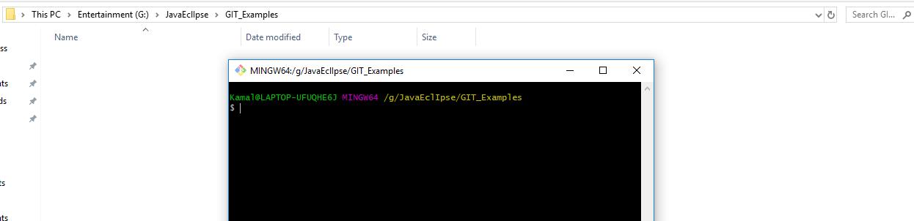

After getting this one to create local repository.. we need to use**git init** command there

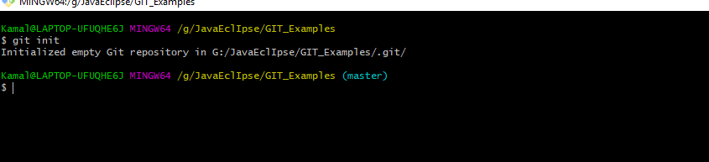

Then it will be create one hidden folder called **.git**it will contain all configuration details..etc.

Here in brackets (master) means master branch repository

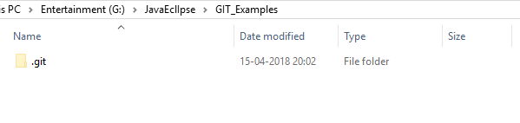

now we have to provide link between local and remote repository...

Below you can understand repo means GIT(available in local system) and remote repo means GITHUB(available in server)

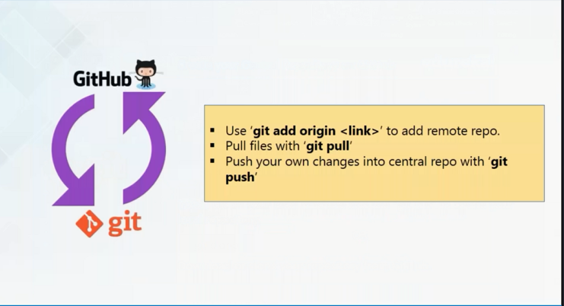

To do so ...**git remote add origin "link(link in web URlgirhub website)"**

**Goto**website and get the link

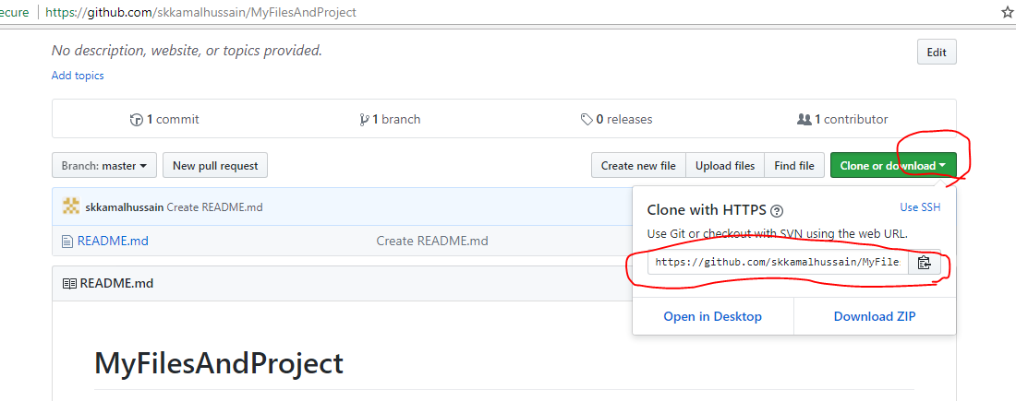

Nowgoto the GIT BASH command prompt..and type below and click on enter..

**git remote add origin "https://github.com/skkamalhussain/MyFilesAndProject.git"**

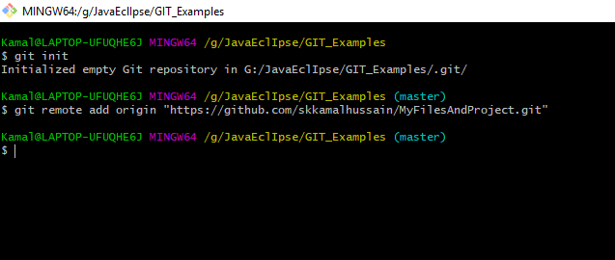

Here no errors so successfulll..... next we need to pull the files from the website(README file currently available there)

Now use command

**$ git pull origin master**

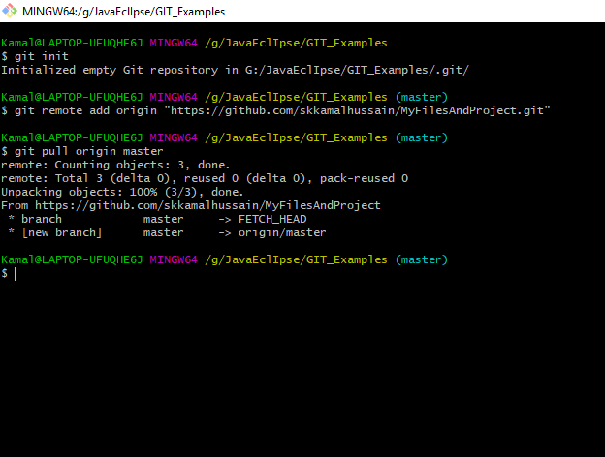

Now you can see one file from remote repo pulled to local folder

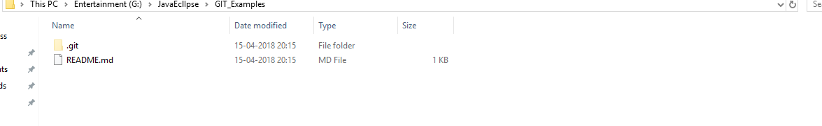

Now our requirement is like create files(manually by mouse right click) in loc and move them to remote repo...

Let’s say we have create one file “webservice” like below..

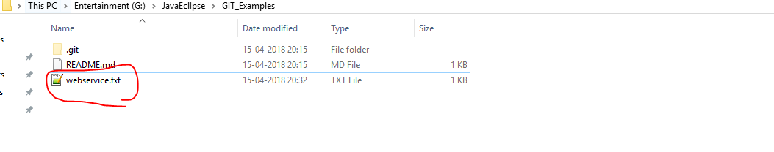

If we are adding or updating files to remote repo..we can check the status of the file by using “**git status**” command

Like below

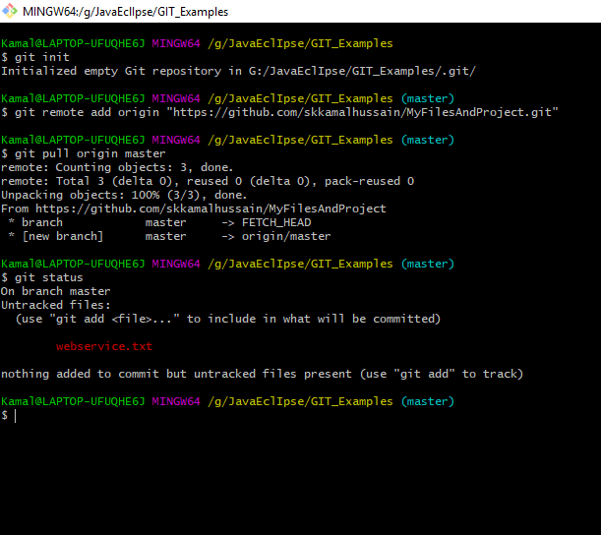

If we are adding new files to repo first those files has to be in **index / Staging** first... to do so... use below command

**->git add nameofthefilewithExtension-🡪 git add webservice**

**->git add –A -** to add multiple files at a time here file names not required only **–A** sufficient.

**Check**  below image for the command..

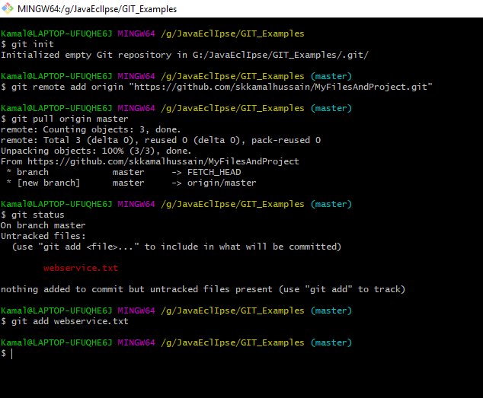

Now check the status of the file by using command “git status”

Check the below image..

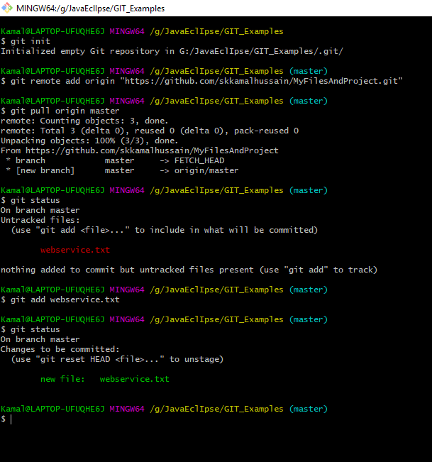

So file is in local system only not yet been moved to local repo.

To do that we need to use **commit** command like below,

**git commit –m “anymessageDescriptionrequired”** ”

Eg: **git commit –m “websierviceFilecommittedtoreremore repo”**

**->git commit –a –m “message ”-> it is for committing multiple files at a time.**

While committing files to local repo no need to mention files names all will go at a time due to **–a**option.

But while doing this we will get some error saying...

“

Kamal@LAPTOP-UFUQHE6J MINGW64 /g/JavaEclIpse/GIT_Examples (master)

$ git commit -m "webserviceFile committed to remote repo"

*** Please tell me who you are.

Run

gitconfig --global user.email "you@example.com"

gitconfig --global user.name "Your Name"

to set your account's default identity.

Omit --global to set the identity only in this repository.

fatal: unable to auto-detect email address (got 'Kamal@LAPTOP-UFUQHE6J.(none)')

”

In order to avoid this issue we need to add user name and mail id to local repo by git commands..

**gitconfig user.name "kamal"**

**gitconfiguser.email "XXXXXXX@gmail.com"**

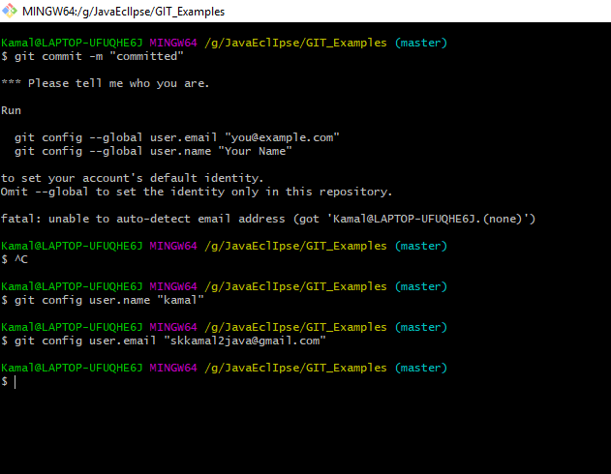

**Clear**command to clear git bash console..

After this try to commit file by using command “**git commit –m “anymessage**”” see below screenshot..

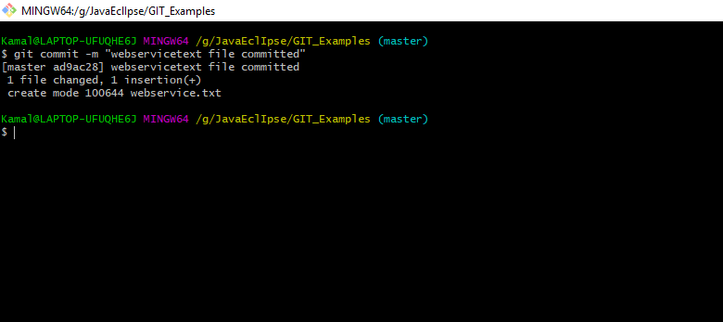

Till now code has been moved to local system to local repository...

**Now our aim is to push code to remote repo...**

Use command like,,,,,,

->git push origin branchname

->git push origin sub1

**It will ask for git hub site user name and password... enter email/password for guthub site..you will ge below**

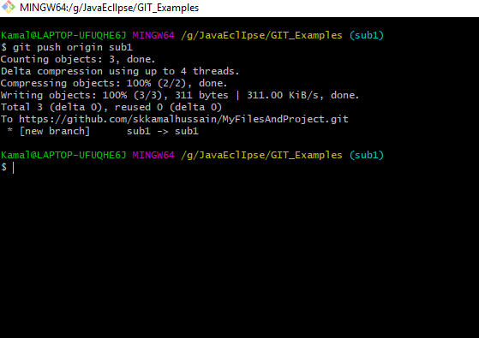

Now goto website and refresh and check under sub branch you will see files that has been committed and pushed.

File 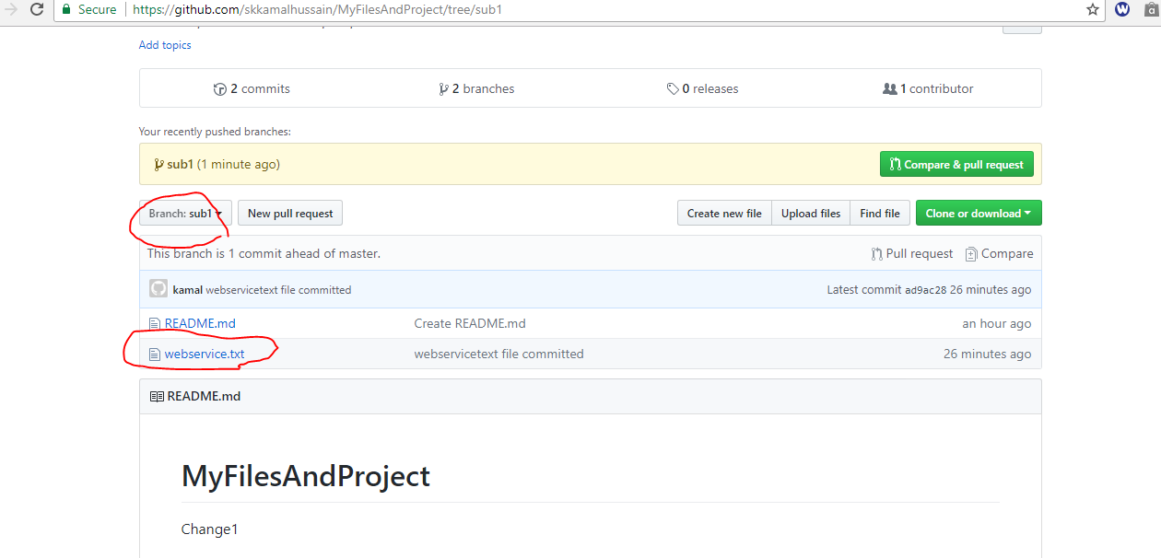

File has been added to sub branch but i want it to add master branch then goto master branch folder in bash..execute same push code..

Like below

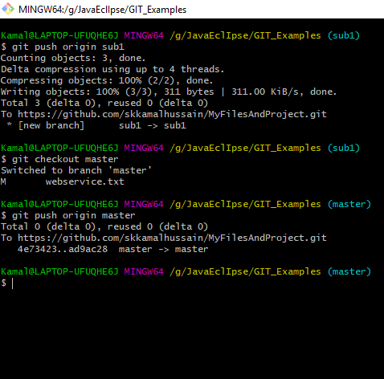

->create file in local system where bash is pointed, let’s say

If you changed file locally.... follow below steps..

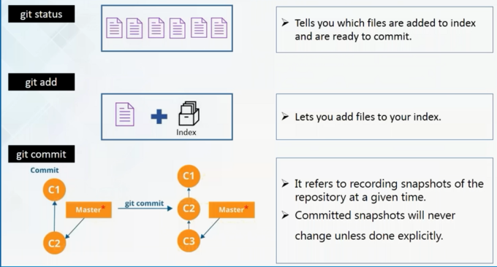

**CREATING NEW BRANCH UNDER MASTER BRANCH**

Creating newbranchundermaster branch ,

🡪**git branch newbranchname**

->currently you are in master branch path to navigate to new branch you created ..we have use command like below..

->**git checkout newbranchname**it is similar to **cd** command in command prompt..

For example below i created new branch name as “sub1” and moved to that branch

Check below image..

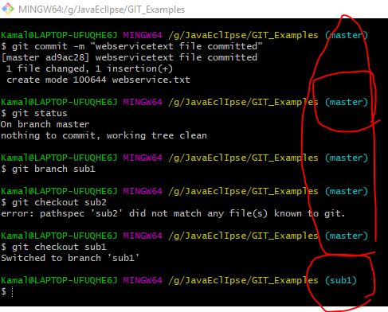

No you can pull you files from master branch to subbranch..

->

gitinit

gitconfig user.name "name"

gitconfiguser.email "anymai.com"

4.git add *

5.git commit -m "some initmsg"

-------------------------

if any changes done to existing file then goto corresponding directory in bash and right click and select an option **git Bash here**next execute the following commands.

1.git commit -a -m "filechangesmessage"

2.git push origin sub.mainpackagenameeg: git push origin sub1

-------------------------------------------------

->

->git checkout

Git reset header

Git statsh push file1 file2 file3

Git stash list

Git stash pull

Git stash pop

Git stash save

Git k

->

->

->

->

->

->

->

->

->

->

->

->

->

->

->

->

->

->

->

->

->

->

->

->

->

->

->

->

->

->

->

->

->

->

->

->

->

->

->

->

->

->

->

->

->

->

->

->

->

->

->

->

->

->

->

->

->

->

->

->

->

->

->

->

->

->

->

->

->

->

->

->

->

->

->

->

->

->

->

->

->

->

->

->

->

->

->

->

<https://www.youtube.com/watch?v=fqjAzEocMCQ>

**BITBUCKET**

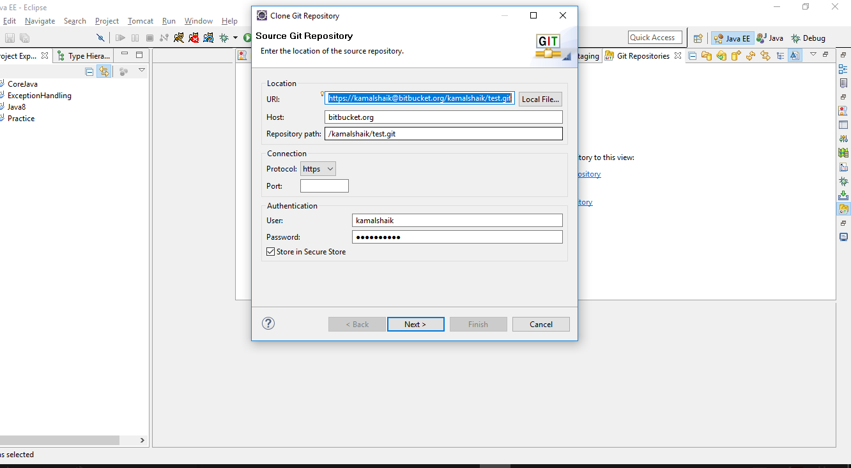

GITBahs Commands:

$ cd g:🡪 to go to different drive

$ cdfolderName/ 🡪 to move into folder through GIT bash command prompt.

|  |  |
| --- | --- |
| **GIT HUB / GIT BASH Commands** | |
| $ cd g: | to go to different drive |
| $ cd folderName/ | to move into folder through GIT bash command prompt. |
| $ clear | To clear gitbash command prompt |
| $ cd .. |  |
| $ ls | To see list of files in cwd(current working directory.) |
|  |  |
|  |  |
|  |  |
|  |  |
|  |  |
|  |  |
|  |  |
|  |  |
|  |  |
|  |  |
|  |  |
|  |  |
|  |  |
|  |  |
|  |  |
|  |  |
|  |  |
|  |  |
|  |  |
|  |  |
|  |  |
|  |  |
|  |  |

1.

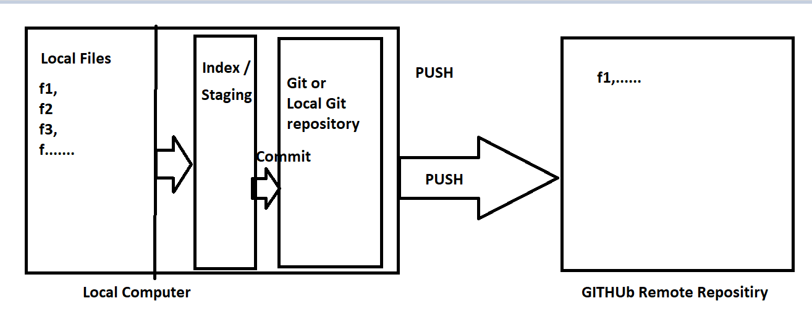

Share already existing project to repository:

First goto portal and create repository like below..

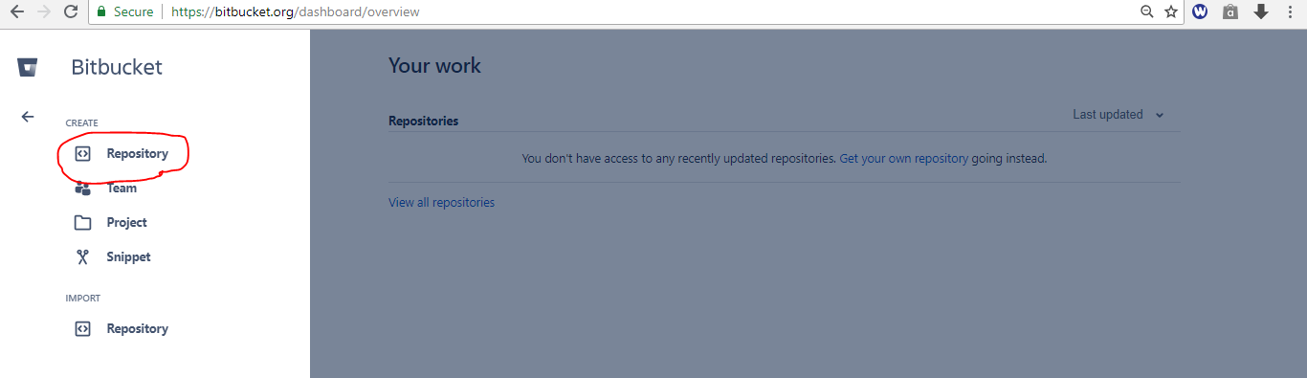

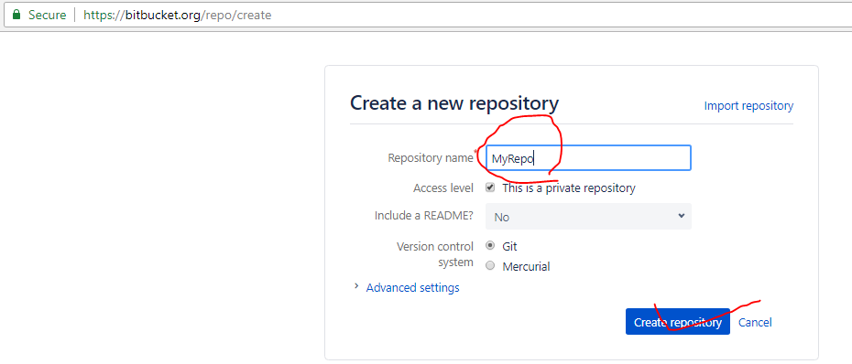

Screen will come like below.

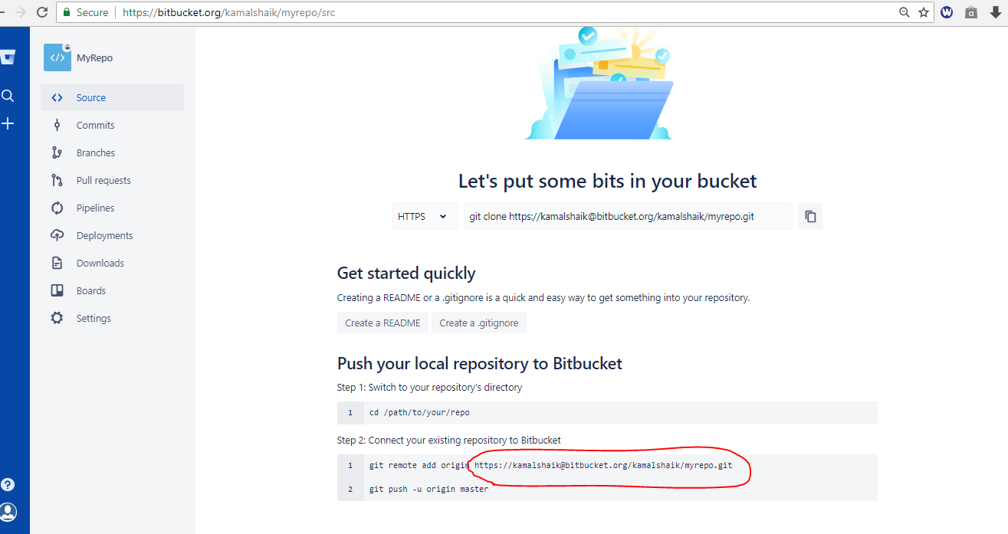

Copy red marked line , it is useful to clone with eclipse.

->Now goto eclipse...Window🡪Show View🡪Other🡪type repositories you will get below details..

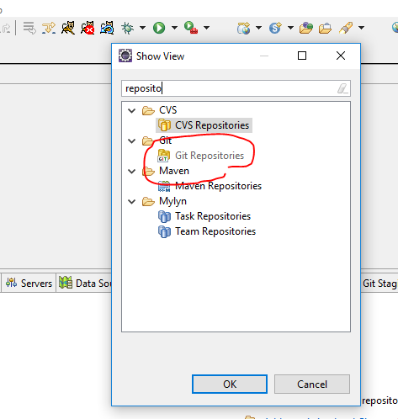

Now select “Git Repositories”, you will see like below..

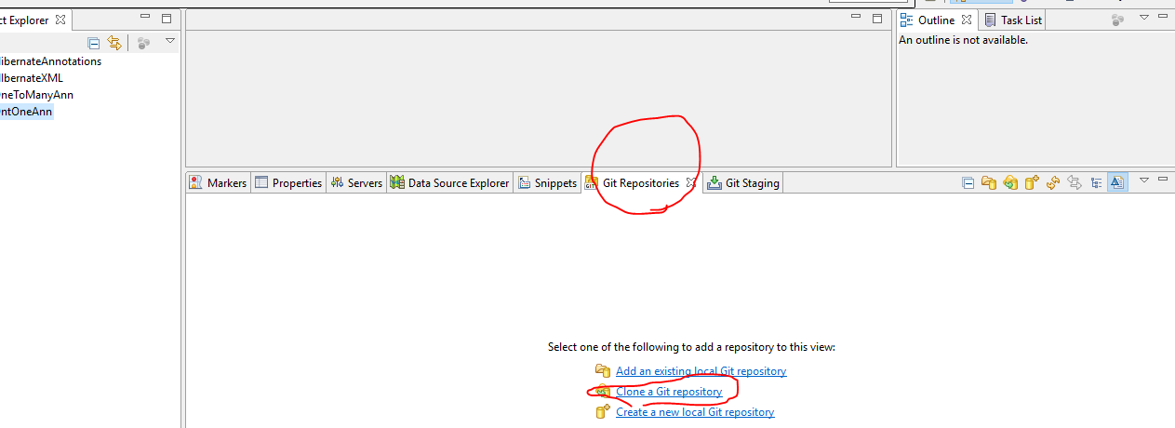

Now click on “Clone a git repository”, you will get below popup..

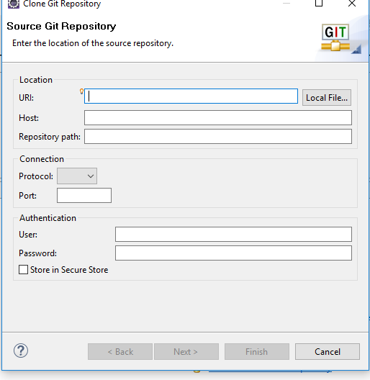

Now we need to paste the URL which is create while creating repository..

Eg: <https://kamalshaik@bitbucket.org/kamalshaik/myrepo.git>

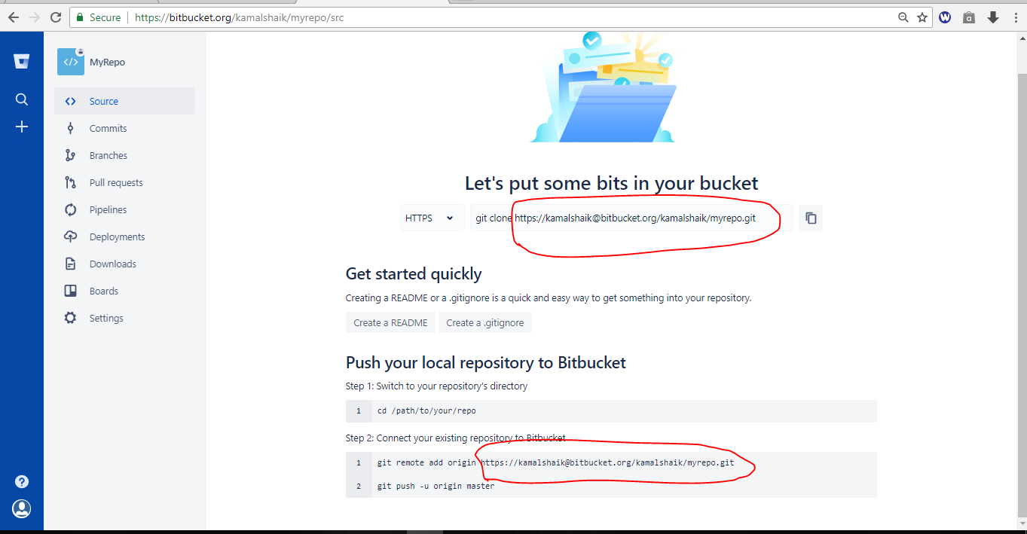

After pasting that URl we will get below view if popup..

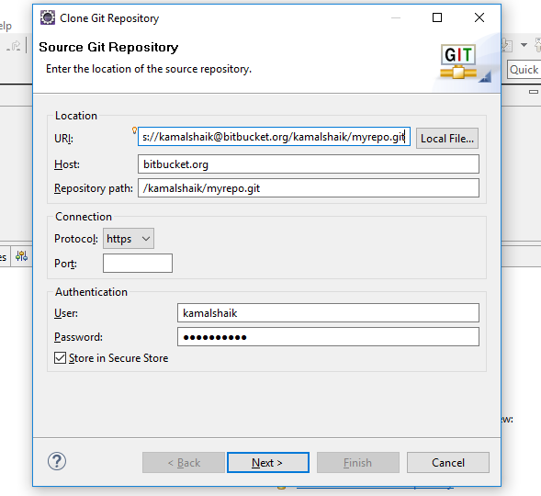

Need to enter user name and password, which are create while creating github account

Next click on next button..

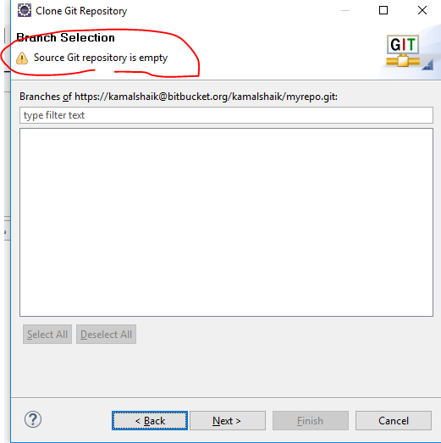

Click on Next button..

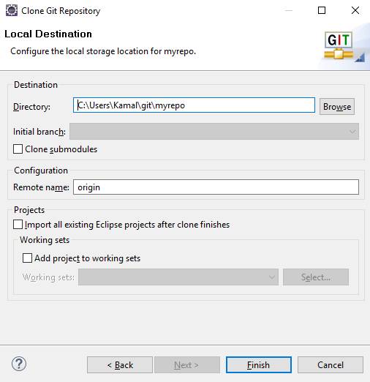

Click on Finish button..

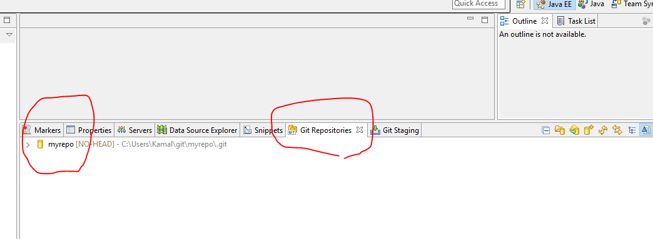

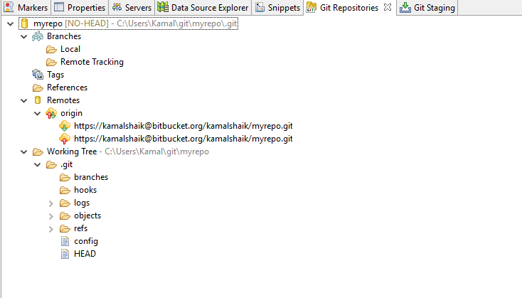

We will get like above repository,,

->Now goto our project..and right click on project..Team🡪Share Project..

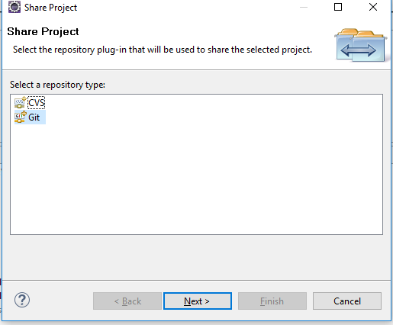

Select Git and click on next..

You will see below...screen...

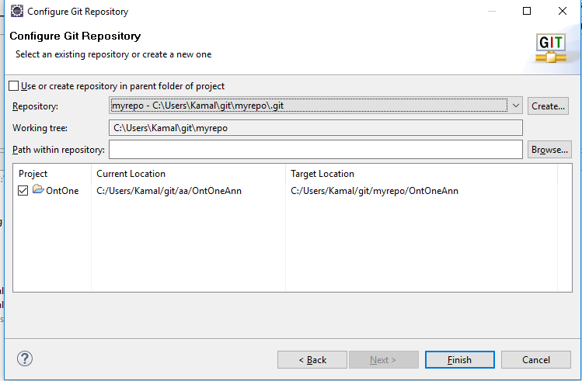

Click on finish..you will see proeject is appended with repo name like below..



->Now right click on project -> Team-> you will see lots of options...->Commit -> you will see window like below..

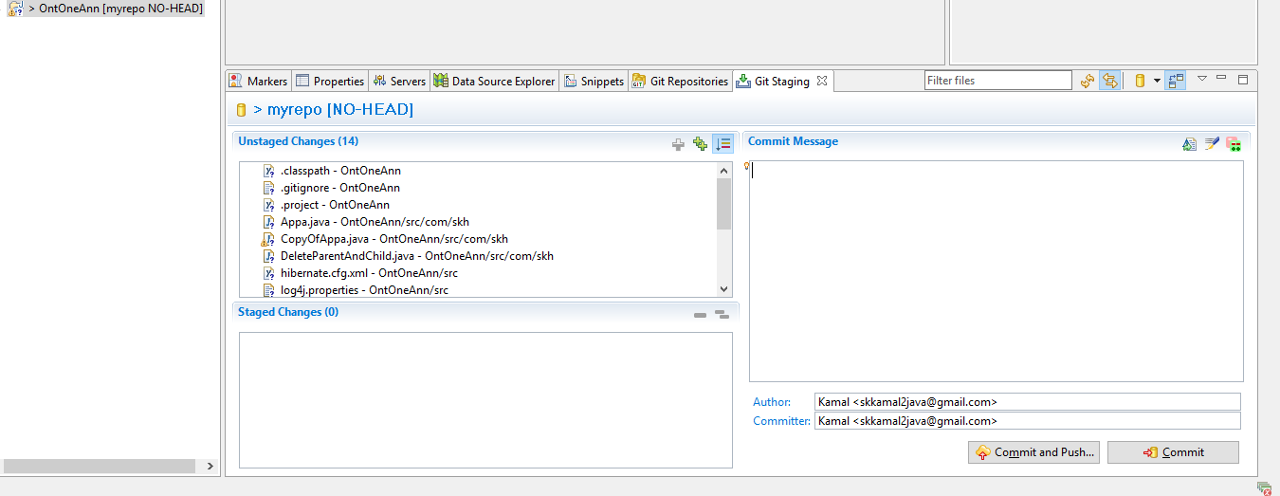

While adding files to index / Staging initially we will get below error, no nee to worry..

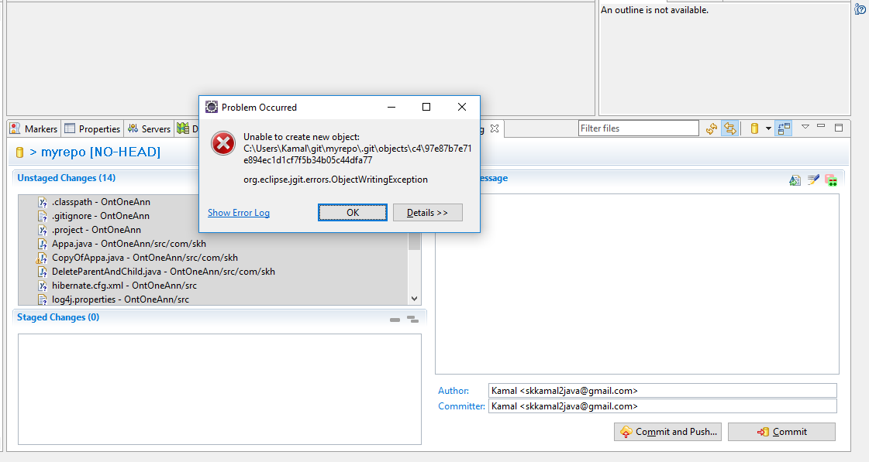

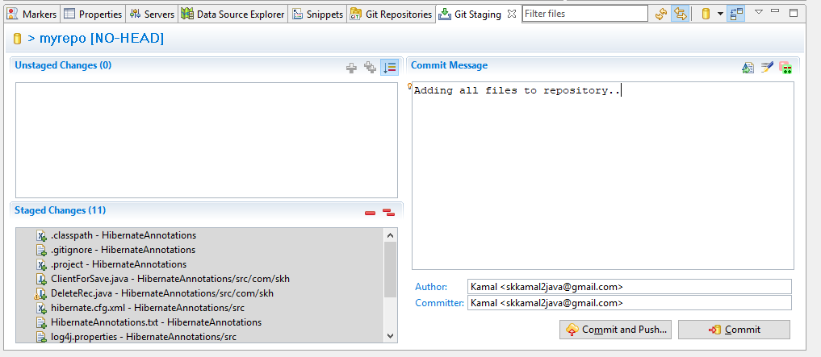

Try to stage multiple times click multiple times..(+ + symbol) you will get like below.



Now give some comments and commit and push...

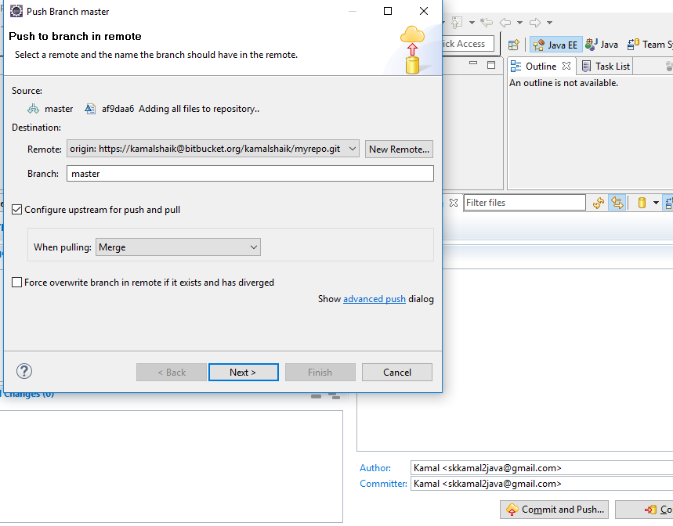

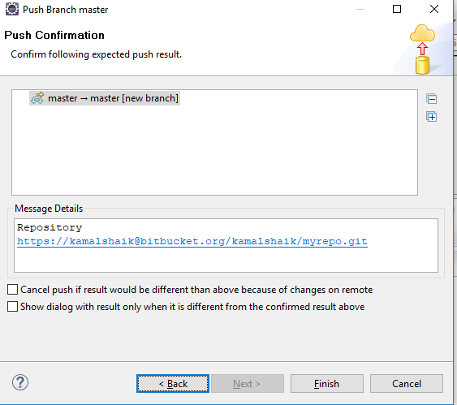

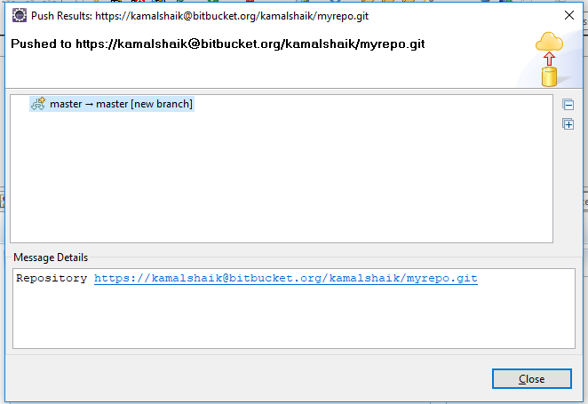

Thats it code is moved to Repository. Now gotobitbucket website and try to observer commits tab or Source tab you will see our project..,

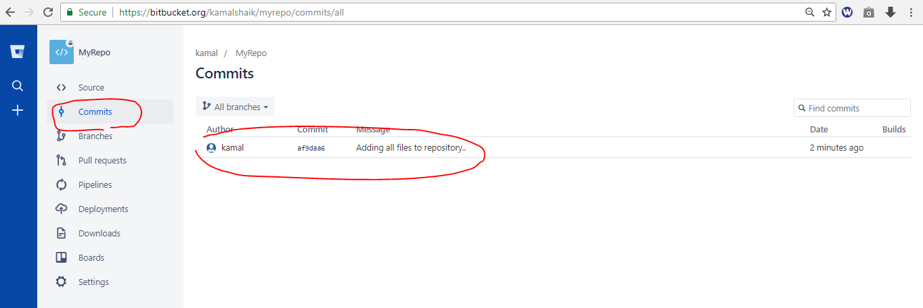

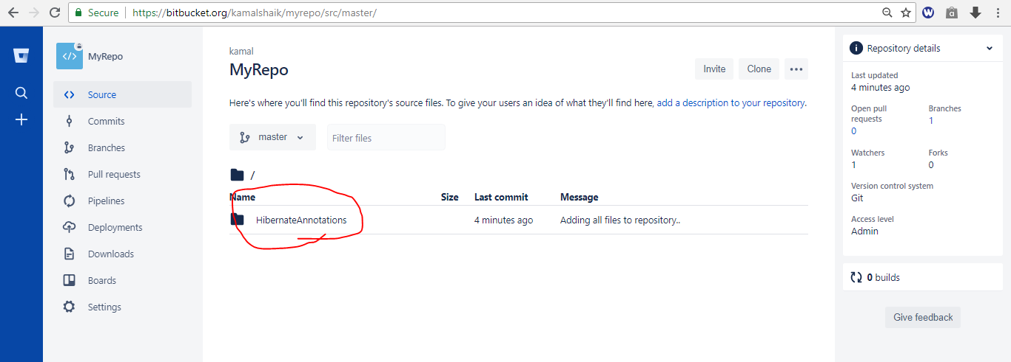

--🡪 Now create separate branch and merge you code from master branch to newly created branch..it is safer because we should not put or maintain our code in Master branch so create new branch..for that create Branch tab in portal and create new

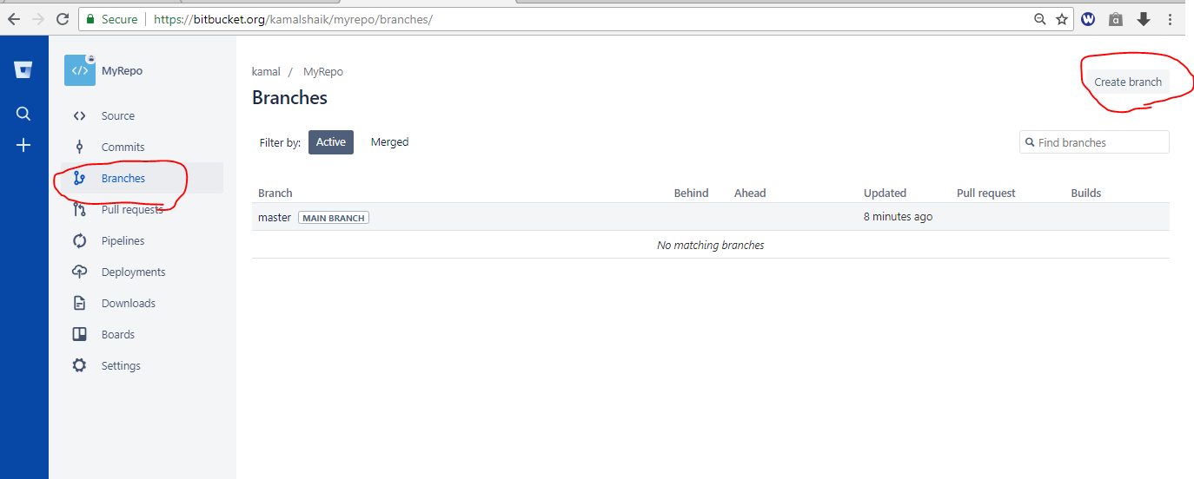

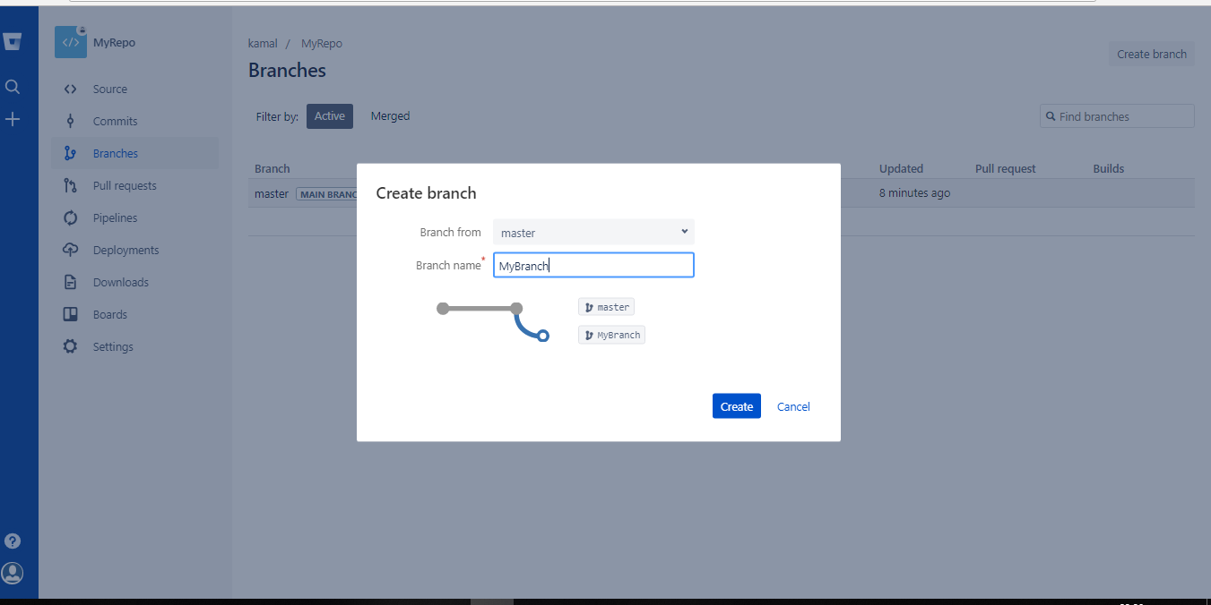

After creating new branch we need to merge your master branch code to newly create branch..

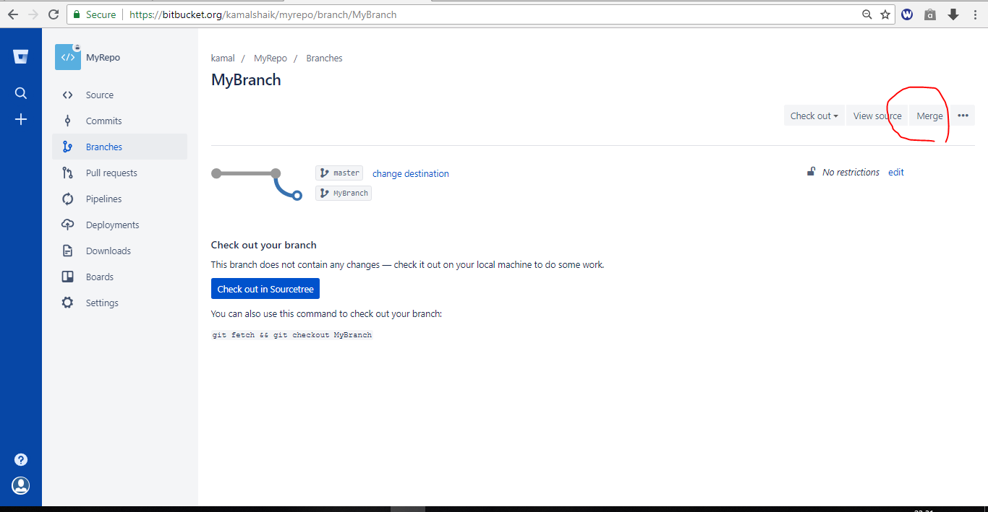

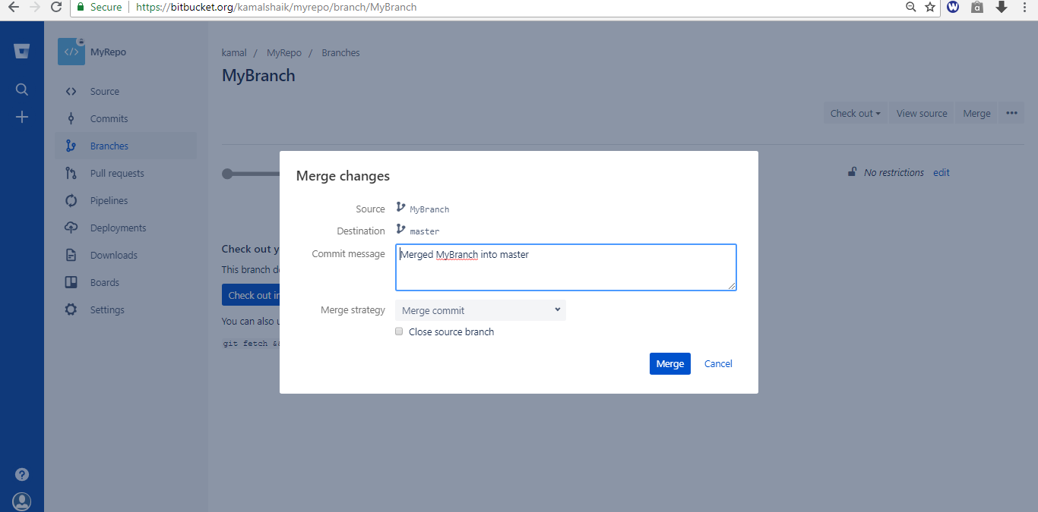

Click on Merge button...

Now goto Source tab and check we will see more branches..

Namely master branch and your newly created branch..

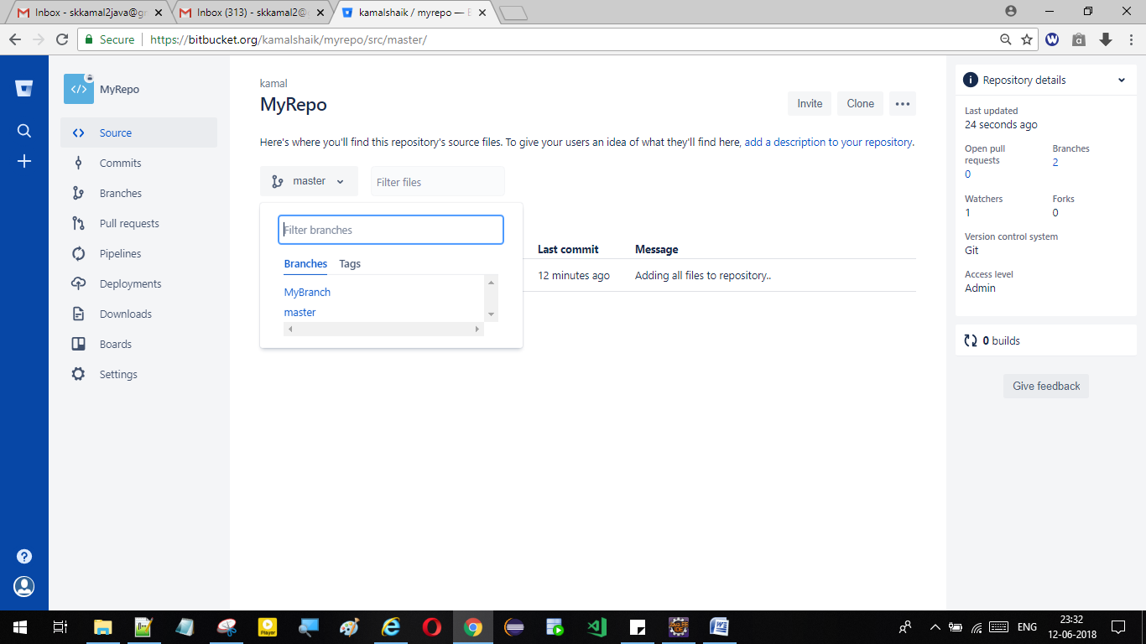

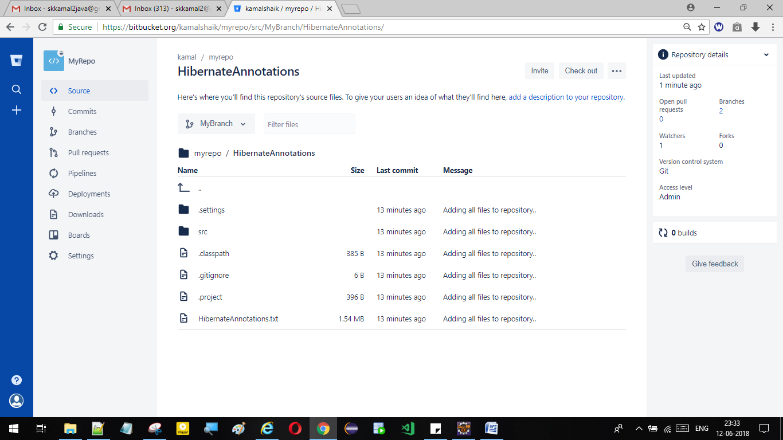

After adding atleast one project to the repo then only we can create new Branch.Other wise not possible to create new branch

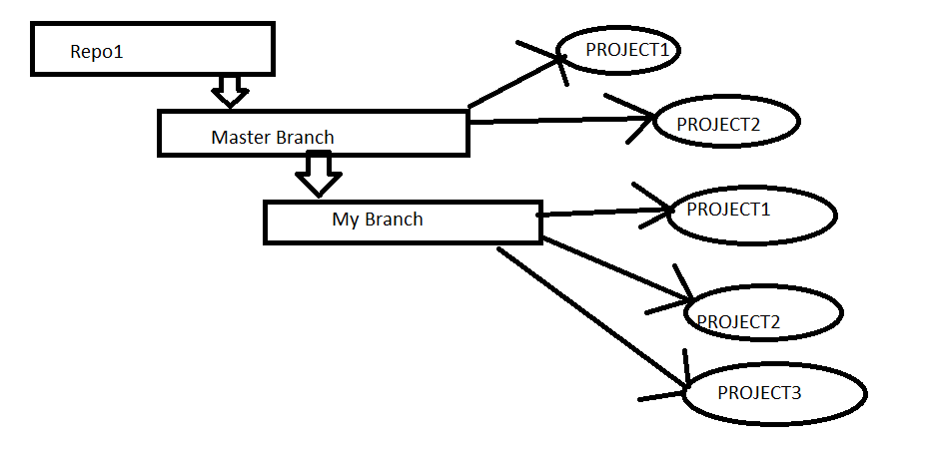.

* Already project in Repo i want to checkout that project to Eclipse means..

Goto eclipse right click on eclipse..

\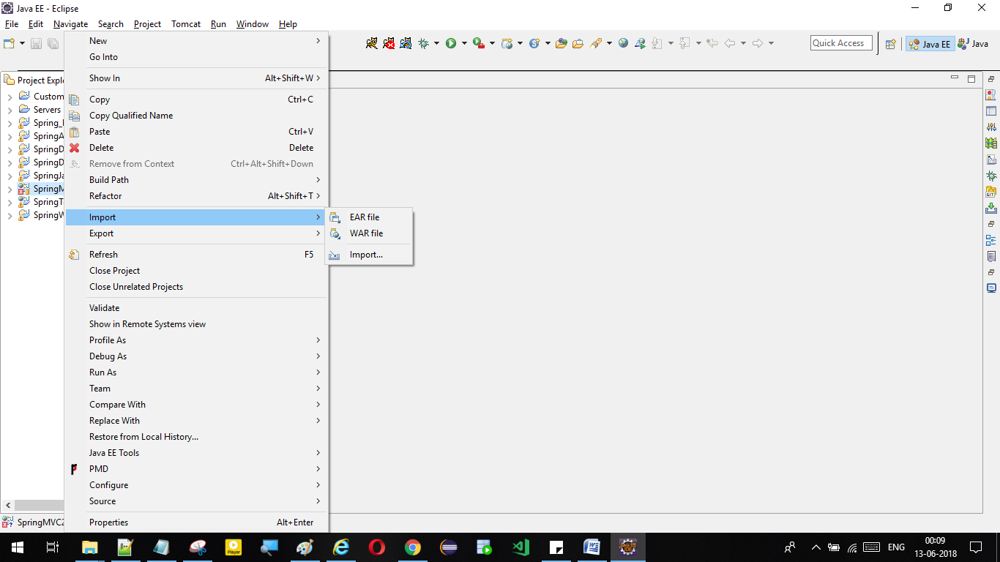

Import...

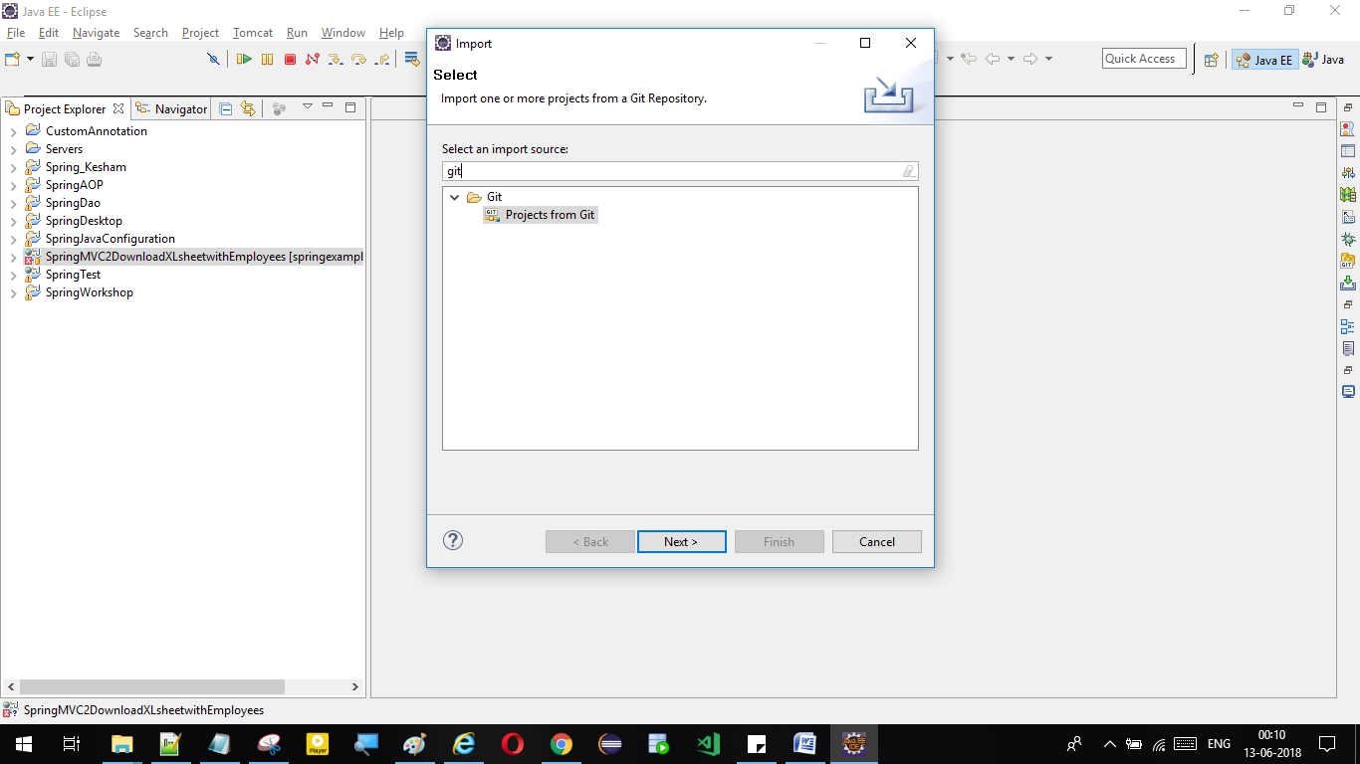

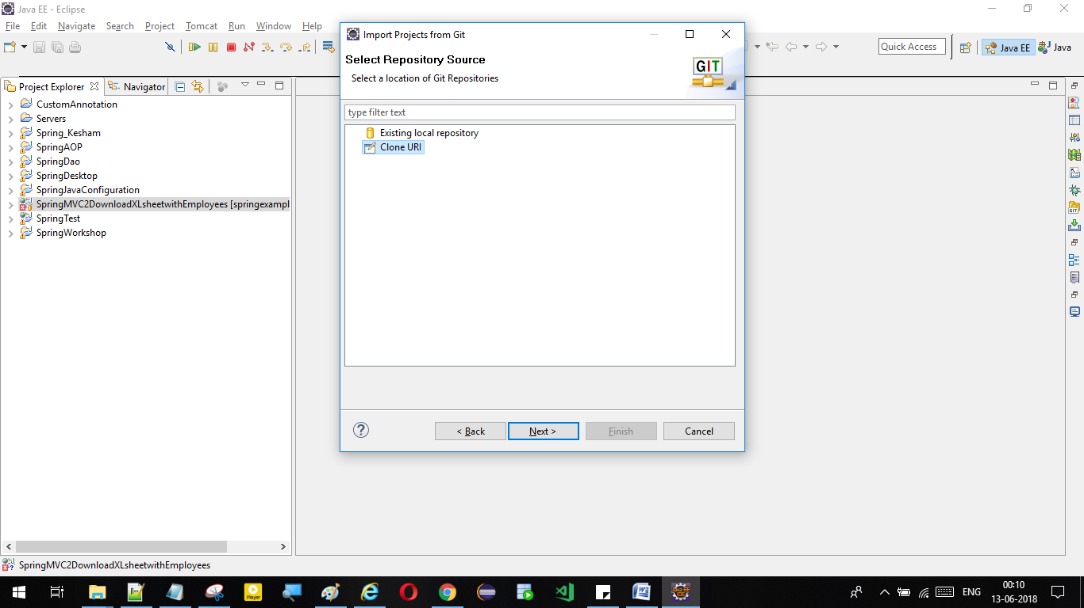

Copy the clone URL and paste here from portal / website..

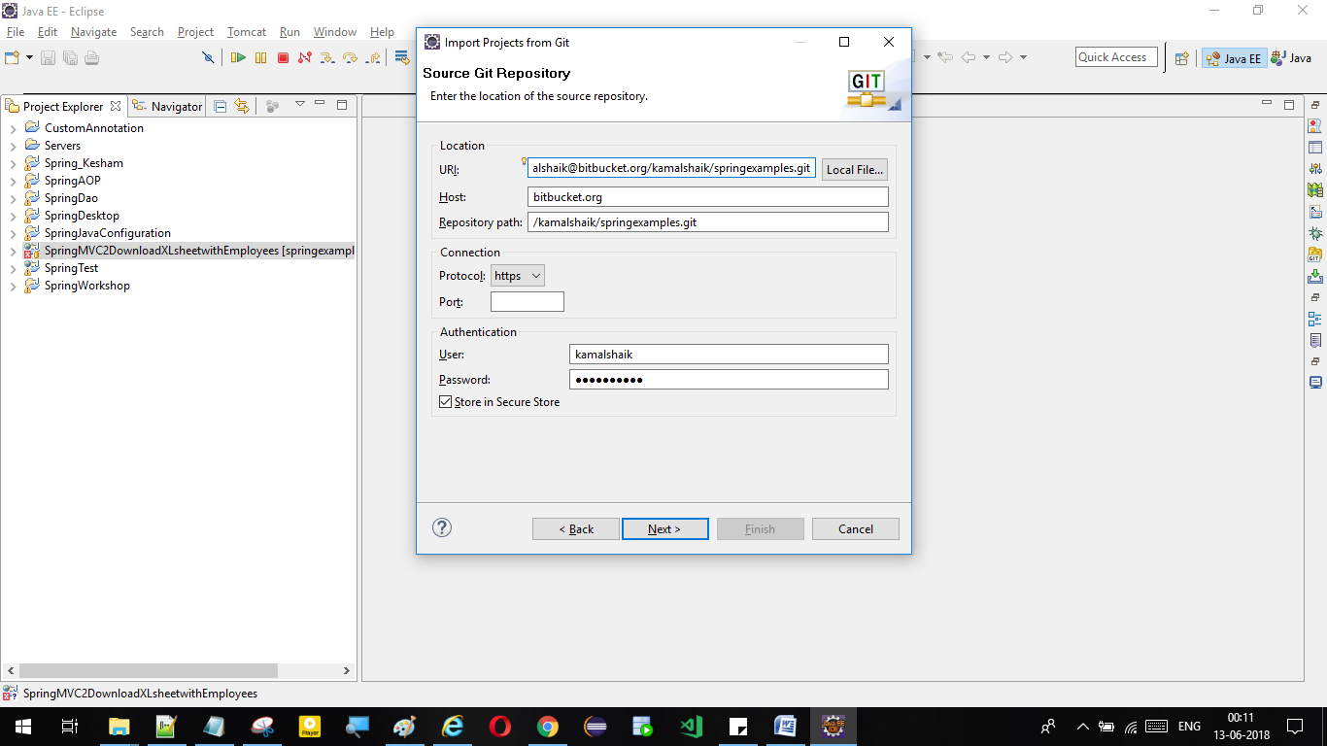

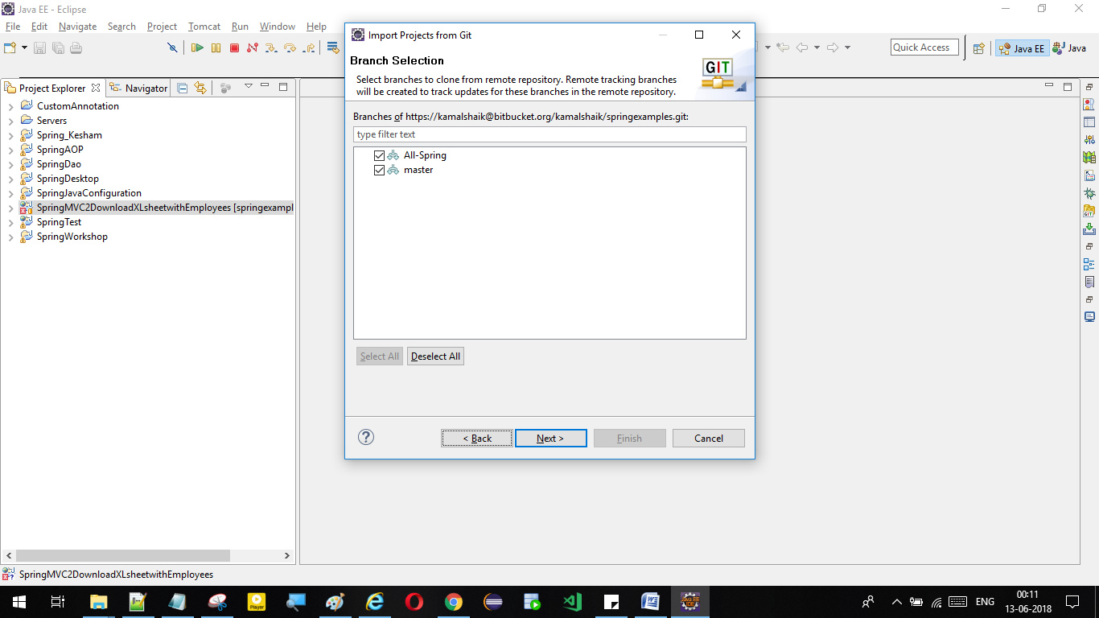

Next...

1.createrepo in portal,

2.clone repo first in eclipse

3.share project to repo,

4.commit and push code to repo.

1.Right click on project🡪Team🡪Share Project🡪

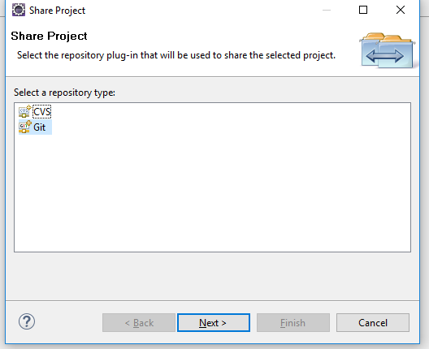

2.Click on GIT🡪

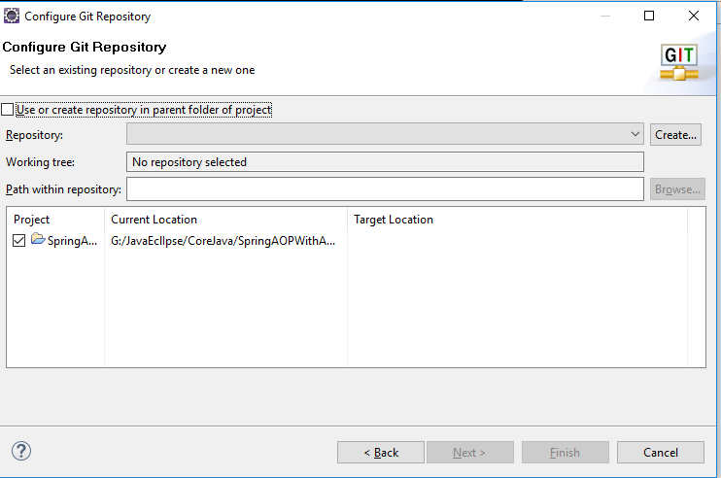

Adding multiple project to BITBUCKET portal:

<https://www.youtube.com/watch?v=WbwIoQYP6no&t=46s>

<https://www.youtube.com/watch?v=HCeBd5GKNO8&t=1236s>

__ git checkout type/branchname ( it is used for switching between branches)